Welcome to Derbyshire County Cricket Club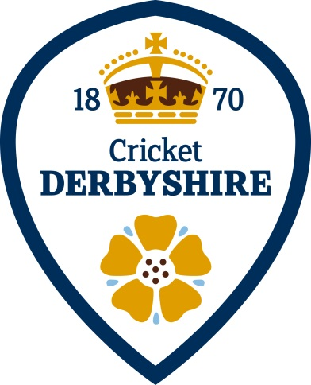

Founded in 1870, Derbyshire County Cricket Club embodies the essence of cricketing tradition and community spirit in the heart of the East Midlands. The Cricket Club based at The County Ground is located at the original Derby Racecourse site, found within the centre of Derby, and is renowned for its rich heritage, passionate fan base, and commitment to fostering talent at every level.

Our club prides itself not only on our achievements on the field but also on our core values that define who we are and how we operate.

At Derbyshire County Cricket Club, we offer more than just cricket; we provide a vibrant social hub where members and supporters alike can experience top-tier hospitality and exciting events year-round. Our facilities cater to a variety of occasions, from matchday hospitality to private functions, corporate events, and weddings.

Throughout the cricket season, our calendar is packed with thrilling events designed to entertain and engage cricket enthusiasts of all ages.

There's always something happening at Derbyshire County Cricket Club so join us and become part of a dynamic community where passion for cricket meets unparalleled hospitality and unforgettable experiences. Visit our website to learn more about our fixtures and events, and up-to-date news on the Club.

Our Values:



**Integrity**: At Derbyshire County Cricket Club, integrity forms the cornerstone of everything we do. We uphold the highest ethical standards, ensuring fairness, honesty, and respect in all our interactions, both on and off the field.

**Passion**: Cricket is more than just a sport to us—it's a passion that drives us to strive for excellence every day. We are dedicated to nurturing this passion in our players, supporters, and the community, fostering a love for the game that transcends generations.

**Inclusivity**: We celebrate diversity and inclusivity at Derbyshire County Cricket Club, welcoming individuals from all backgrounds and abilities to participate in and enjoy cricket. Our club is a place where everyone feels valued and respected, creating a supportive environment for personal and collective growth.

**Community**: Beyond cricket, we are committed to making a positive impact in our community. Through outreach programs, partnerships, and charitable initiatives, we aim to use the power of sport to inspire and unite people across Derbyshire.

**Innovation**: Embracing innovation is key to our continuous improvement and success. We adapt to new challenges, explore new ideas, and invest in the future of cricket, ensuring Derbyshire County Cricket Club remains at the forefront of the sport.Top of Form

What We Can Offer You:

* **Competitive Salary:** dependent upon the experience you can offer us
* **Paid Holidays:** 25 days paid holiday plus bank holidays
* **Free On-site Parking:** convenient and free parking for all employees
* **Cricket Match Tickets:** 2 free tickets to every Derbyshire County Cricket Club home match.
* **Employee Assistance Programme:** free confidential supportive services to help with a range of issues such as medical, legal and financial wellbeing as well as assistance with quitting smoking, improving your diet, a get fit programme and help with your mental health - it is there if you need it
* **Discounts:** 15% off services with a local Solicitors and Tastecard offering savings across multiple categories ie. dining out, cinema tickets, supermarkets and attractions
* **Clothing:** Staff will receive some Company issued clothing
* **Social Events:** invitations to social events such as the Player of the Year Awards, pre-season friendly evening and a Christmas meal - fostering camaraderie and team spirit.
* **Regular Staff Meetings: the opportunity for keeping up to date with important information and for communication and collaboration across the Club (often with food provided!).**

Bottom of Form