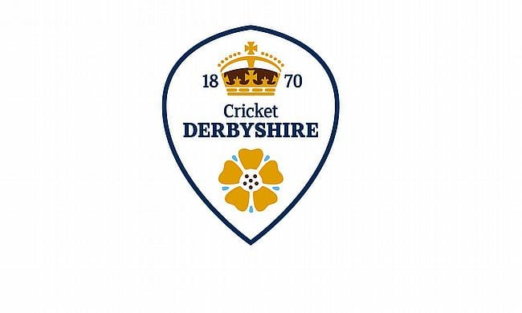

**Derbyshire Boy’s Pathway Observation Process 2025/26 – u13 to u18 only**

Following on from last year’s successful video submission process, we will once again welcome video footage demonstrating batting, bowling and wicket keeping skills for the following 2026 age groups. **U13, U14, U15, U16 & U18s only**. Applications are on a self-nominated basis, and we only ask that they are made by persons over the age of eighteen, i.e. parents. For safeguarding reasons, we will not respond directly to applications from persons under the age of eighteen. The video should be short and concise and give a clear view of the player's primary skill. Coaches viewing the footage will know within a couple of shots/deliveries if we would like to then see the player in person, so there is no need for long, extensive videos.

Applications will open on Monday 11 August. Please do not submit before then! The footage should be sent to **boyspathwaytrials2025@derbyshireccc.com.** For batters, please evidence a selection of both front foot and back foot shots showing an intent to strike the ball. For bowlers, evidence of pace, swing or spin would be beneficial, as well as the run-up/approach (this does not require a batter). Wicket Keepers should evidence both standing up to the stumps and standing back. All–rounders (definition of being selectable on either skill) should submit two videos showcasing each discipline.

Current Derbyshire CAG Pathway players are not required to submit footage; you will be contacted separately for the next phase of trials. **The cut-off date for video submissions is 5pm on Friday 19 September 2025.** You will receive an automated email confirming receipt of your submission. Please do not contact us directly for feedback. Footage will be reviewed by the Head of Boys Talent Pathway at Derbyshire CCC, with current readiness and future potential assessed in each technical skill set. Successful applicants will only be contacted once submissions have closed and will be invited to phase II trials, which will take place over 3 sessions during November at Derbyshire County Cricket Club. Individual feedback will not be given to unsuccessful submissions.

At this stage, to remove any perceived bias, **please do not supply us with any player names, schools, clubs etc.** All we ask for at phase I is the player’s date of birth so that we know the age group the player is applying for.

Submitted data will be securely held on password protected systems with Derbyshire County Cricket Club with adherence to protocols in terms of storage, retention & deletion of data.

**Very Important - Eligibility to trial for Derbyshire Boys Pathway:** ECB regulations state that a player may not be part of more than 1 County Pathway Programme. If a player has been involved with another county in the past 12 months, please submit a release letter from that county along with your video submission. Likewise, please do not apply for Derbyshire Trials if you have, or are planning to trial at another county or minor county.

**Players in the age groups U10 – U12:** Under 10,11, and 12 cricket will now fall under the remit of the ECB’s new Early Engagement Programme and will sit separately to the County Age Group Pathway. Further details on the content and structure of the programme will be released later this summer as this programme will only commence in December.